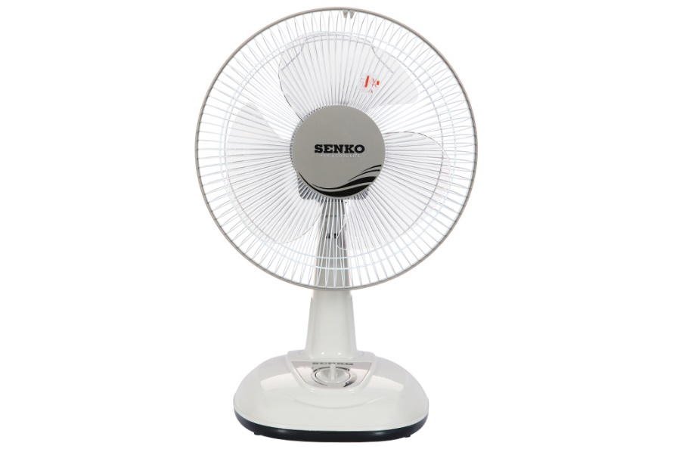

**350,000 VND**

~~399,000 VND~~(-12%)

**Technical specifications Senko 3-blade table fan B1213 40W**

* Fan Type:

[Table fan](https://www.dienmayxanh.com/kinh-nghiem-hay/cac-loai-quat-pho-bien-tren-thi-truong-845793#quat-ban) - 40W - 3 wind levels

* Fan diameter:

3 wings - 29 cm

* Wind mode:

Normal wind

* Dashboard:

Rotate button

* Motor type:

Silver brazing

* Utilities:

The switch and wire connection protection parts are made of fireproof material. The fan cage has a small fan blade gap

* Size, volume:

Width 26.5 cm - Height 54 cm - Depth 27.5 cm - Weight 3.1 kg

* Brand of:

Vietnam

* Launch year:

2019

Introducing the company 

- Vietnamese brand.

- Established in 1998.

- With the mission "Cooling for life", SENKO electric fans meet all customer needs and are the perfect choice for every home for table fans, hanging fans, mezzanine fans, standing fans, ceiling fans, etc. .

- High quality, beautiful design, and energy saving are the core criteria in every Senko electric fan product.

***Senko B1213 table fan has compact design, eye-catching colors, 40W operating capacity for effective cooling with 3 blades, brass motor with 100% durable copper wire material, suitable for cooling in spaces. medium and small.***

**Product design**

- Compact design [table fan](https://www.dienmayxanh.com/quat-ban) , suitable for placing in many positions, suitable for use in small rooms, desks, reading areas,... bright, eye-catching colors, beautifying the space.

- 3 fan blades with a blade diameter of 29 cm effectively cool the air, creating a wide breeze, quickly dissipating cool air, creating a comfortable feeling for the space used.

- The fan cage has a small gap between the fan blades, so human fingers cannot touch the fan blades, helping the user not touch the electrical parts inside the fan.

- The power cord length is 194 cm, making it convenient to move the fan during use.

- Switches and wire connection protection parts are made of fireproof material, heat-resistant enough, ensuring safety when used.

**Motor type and operating capacity**

- Equipped with a brass motor with 100% copper wire to help the fan operate smoothly, durable, less susceptible to corrosion, allowing the fan to be used well in quiet spaces.

- Operates effectively with a capacity of 40W to help cool quickly, providing air flow up to 37.9 m 3 /minute.

- The product is granted a 5-star energy label to help save electricity effectively.

See more:  [Tips for preserving electric fans](https://www.dienmayxanh.com/kinh-nghiem-hay/meo-bao-quan-quat-dien-536092)

**Wind level, wind mode**

- [Senko B1213 fan](https://www.dienmayxanh.com/quat-senko) has 3 blades with a diameter of 29 cm with 3 wind levels low - medium - high to help you comfortably customize according to your needs.

- [The fan](https://www.dienmayxanh.com/quat) has a normal wind mode that helps the fan blow out the wind at a steady speed without alternating rhythms of strong and weak times.

**Dashboard**

The rotary button control panel is easy to operate and customize 3 wind levels according to user needs.

[*Senko B1213 table fan*](https://www.dienmayxanh.com/quat/ban-senko-b1213)*has a compact design, 3 blades with a capacity of 40W for effective cooling, equipped with a brass motor with 100% copper wire to help the fan operate durably and smoothly. It is a suitable product for many applications. Families with small and medium spaces: living room, motel room,...*